FAA 2019: Dr. Eckel hosting VIP event prior to Bangkok conference
For three days, feed experts and specialists met at this year’s FeedAdditives Asia conference in Bangkok to address the industry’s most pressing issues and needs. The conference was presented by FeedInfo News Service. With its impressive selection of expert speakers, enlightening panel discussions with industry leaders and practical seminars, FAA is rightly regarded as one of the leading events in the region for livestock producers, industry leaders and academics alike.
In celebration of the company’s 25th anniversary, Dr. Eckel hosted an exclusive pre-event to the conference on June 25th for loyal customers and esteemed friends. Here, Dr Antje Eckel spoke about Hidden Champions, leadership and the most influential lessons for her and the company. » Today we are proud to celebrate 25 years of development, learning and innovation«, says Antje Eckel. »And there is one thing I promise you: We will make sure that you get more innovations in the coming years from us.
Human health and animal welfare are still the focus of Dr. Eckel’s business activities, as they were 25 years ago, and will continue to be in the future. In his speech, Vice President Sales Dr Bernhard Eckel highlighted the company’s approach to zero hunger, good health and well-being.
In the evening, this exciting and emotional event peaked out with a delightful dinner at Millenium Hilton’s scenic terrace restaurant with a spectacular view over the illuminated riverfront and the boats sailing majestically on Chao Phraya River.

Dr. Eckel wishes to thank all participants in the event for making our celebration such a delightful and unforgettable experience. We are grateful for our customers’ trust in our work and products. Empowered by this, we will continue striving for a better, sustainable future.
About Dr. Eckel
Dr. Eckel Animal Nutrition GmbH & Co. KG is one of the leading international suppliers of modern feed additives and solutions that improve animal nutrition. Top products as well as targeted research and development make the company a preferred partner in the compound feed industry and in agriculture. Its portfolio includes its own high-quality products as well as select products from international manufacturers. Since its inception nearly 25 years ago, the company has successfully developed dynamic and innovative solutions for animal nutrition. Innovative feed additives, which uniquely combine efficiency, sustainability and animal welfare, make Dr. Eckel a pioneer of global animal nutrition. The creative solutions promote healthy animals, profitable production and overarching responsibility. Hence, innovation focuses on highly topical issues related to animal nutrition, such as feed hygiene, food safety, resource efficiency and animal welfare. Dr. Eckel Animal Nutrition operates in Germany and in more than 40 other countries, generating €20 million in revenue.

Projections
This press release may include projections based on current assumptions and forecasts made by the management of Dr. Eckel Animal Nutrition GmbH & Co. KG. Various risks—both known and unknown—uncertainties and other factors may cause the actual results, financial situation, development or performance of Dr. Eckel Animal Nutrition GmbH & Co. KG to differ significantly from the estimates provided here. Such factors include those described by Dr. Eckel Animal Nutrition GmbH & Co. KG in published reports. Dr. Eckel Animal Nutrition GmbH & Co. KG shall accept no liability whatsoever for updating such projections and adjusting them to future events or developments.

Links:
https://www.dr-eckel.de/en/welcome/
https://www.dr-eckel.de/en/news-2/

Contact
Andrea Dietrich
PR & Communication Manager
Tel. +49 2636 9749-48
a.dietrich@dr-eckel.de

Selected photographs, more and in high-resolution on request

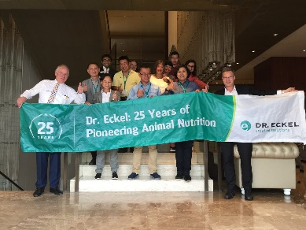
Dr. Eckel staff and guests at pre-event

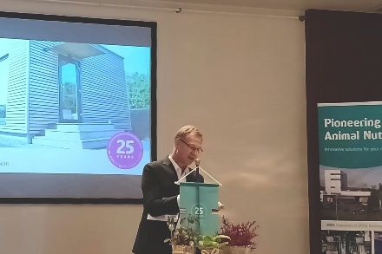
Managing director Thailand, Dr. Andreas Lewke
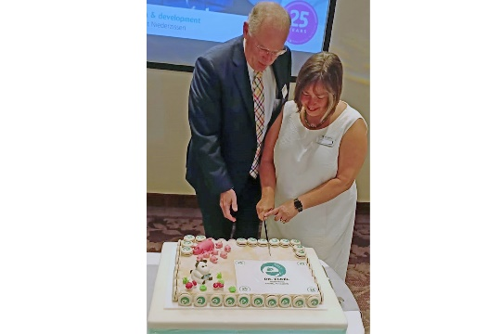
CEO Dr. Antje Eckel and Vice President Sales Dr. Bernhard Eckel cutting company’s 25th anniversary birthday cake
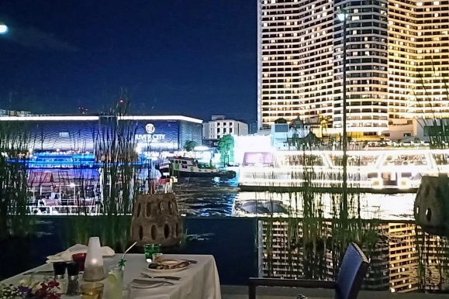
View from Millenium Hilton’s Flow restaurant terrace

