Dr. Eckel: A new face in top management
Dr Francesca Blasco takes over Product Development and Innovation.
Niederzissen. On 1 February 2019, Francesca Blasco became Vice President Product and Innovation, a newly created position at Dr. Eckel Animal Nutrition, joining Dr Antje Eckel (CEO), Dr Bernhard Eckel (Vice President Sales) and Sabine Felten (Head of Finance) in the company’s top management. She will be responsible for the development of the company’s new and existing innovative product solutions.
Dr Antje Eckel, who founded the company 25 years ago, is extremely pleased with the acquisition: “Francesca is a valuable asset to Dr. Eckel, both professionally and personally. She has many years’ experience in animal nutrition and is also an accomplished and proficient manager with first-hand knowledge of the tasks and challenges of product development. Her passion for our industry and our products is evident in all she does.”
Francesca Blasco comes from Catania, Sicily. After studying chemistry at the University of Catania, she obtained her doctorate in Technical Biochemistry in Stuttgart, Germany. She initially worked in Norway, subsequently moving to Switzerland and the USA. Most recently, the mother of two was Director Research and Development at a company in the feed additives sector in Singapore. Besides her native Italian, Francesca is fluent in German and English. The passionate dancer unwinds with music, family time and good food.

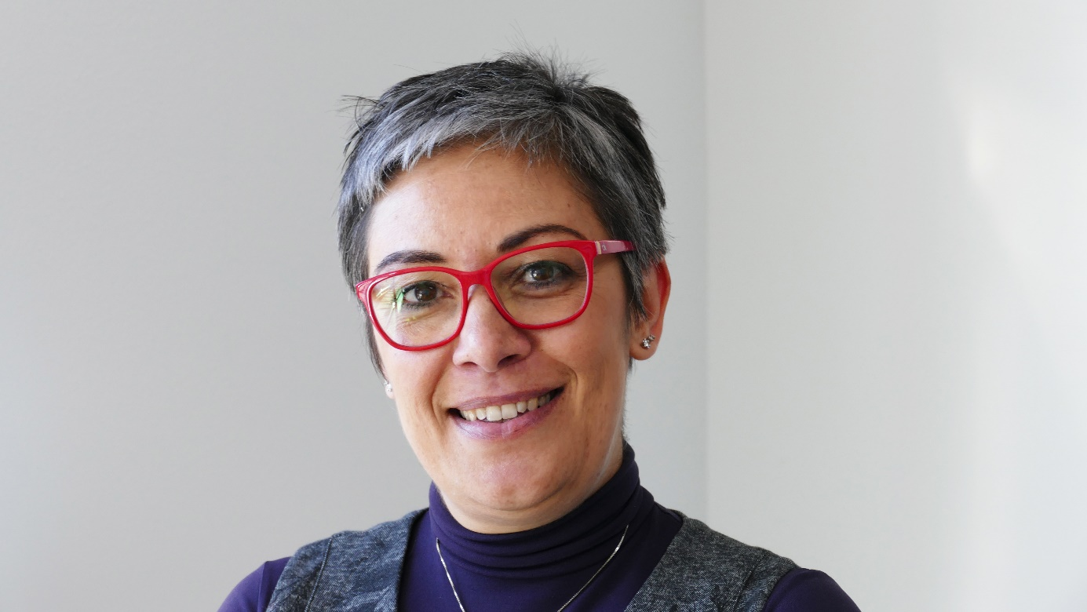

About Dr. Eckel
Dr. Eckel Animal Nutrition GmbH & Co. KG is one of the leading international suppliers of modern feed additives and solutions that improve animal nutrition. Top products as well as targeted research and development make the company a preferred partner in the compound feed industry and in agriculture. Its portfolio includes its own high-quality products as well as select products from international manufacturers. Since its inception 25 years ago, the company has successfully developed dynamic and innovative solutions for animal nutrition. Innovative feed additives, which uniquely combine efficiency, sustainability and animal welfare, make Dr. Eckel a pioneer of global animal nutrition. The creative solutions promote healthy animals, profitable production and overarching responsibility. Hence, innovation focuses on highly topical issues related to animal nutrition, such as feed hygiene, food safety, resource efficiency and animal welfare. Dr. Eckel Animal Nutrition operates in Germany and in more than 40 other countries, generating €20 million in revenue.

Projections
This press release may include projections based on current assumptions and forecasts made by the management of Dr. Eckel Animal Nutrition GmbH & Co. KG. Various risks—both known and unknown—uncertainties and other factors may cause the actual results, financial situation, development or performance of Dr. Eckel Animal Nutrition GmbH & Co. KG to differ significantly from the estimates provided here. Such factors include those described by Dr. Eckel Animal Nutrition GmbH & Co. KG in published reports. Dr. Eckel Animal Nutrition GmbH & Co. KG shall accept no liability whatsoever for updating such projections and adjusting them to future events or developments.

Links:
https://www.dr-eckel.de/en/welcome/
https://www.dr-eckel.de/en/company/

Contact
Andrea Dietrich
PR & Communication Manager
Tel. +49 2636 9749-48
a.dietrich@dr-eckel.de

