Dr. Eckel’s innovative product in 2018: AirFresh
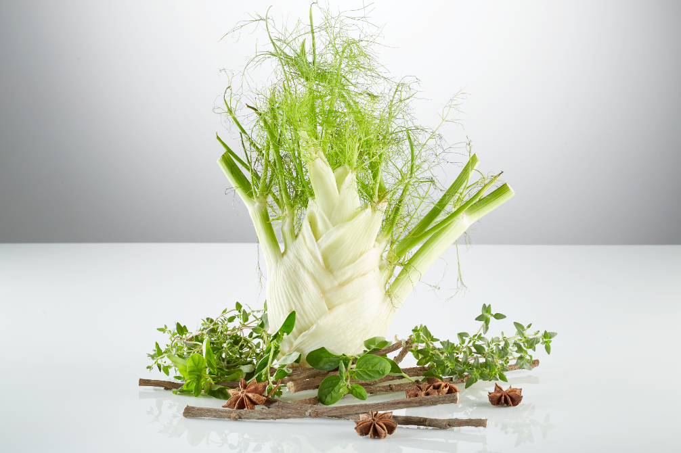

Respiratory disease is a well-known and widespread problem in animal husbandry: in poultry, pigs and calves. Frequently, in addition to making changes in terms of management (such as the litter or the barn climate), the solution is to ‘defend against pathogens’ with both emergency and prophylactic care. Dr. Eckel’s new product AirFresh has a supportive and preventive effect on the respiratory tract and improves lung function. This demonstrably reduces the amount of medication administered.

Essential oils are easy to dose
AirFresh, a combination of essential oils and plant extracts, is produced using our innovative soft-shell process that preserves the active ingredients. It has a mucolytic and expectorant effect, thus supporting lung function in livestock, particularly in poultry, pigs and calves. The essential active ingredients are released in the animal’s stomach and therefore can have a specific effect. Due to the innovative manufacturing process, the essential oils can be easily and precisely dosed, making their use cost-effective. AirFresh enhances animals’ performance as a result of their improved welfare and overall condition, reduces the amount of medication administered and thus simultaneously affects the animals’ health, welfare and performance.
Innovative Soft-Shell process
The beneficial effect of herbal ingredients and extracts on the lungs is common knowledge in human medicine. However, their application in animal nutrition to date can hardly be described as cost-effective. AirFresh has changed this. AirFresh contains specific plant extracts in high concentrations. The active ingredients are incorporated within the specially developed soft shell, which protects them from process-related effects and releases them specifically in the upper gastrointestinal tract. This is what enables the desired effect in the lungs in the first place: they primarily stimulate the production of mucus in the bronchi, which is subsequently forcibly removed from the bronchi by expectoration.

Less medication administered
AirFresh helps reduce the use of medication. This was demonstrated in a field test: less medication, antibiotic treatment in particular, was required due to AirFresh. This means lower direct costs for producers and less of a threat to animals, humans and the environment. AirFresh is evidence that investing in improving animal welfare is worthwhile.

URLs:

www.dr-eckel.de/en/welcome
www.dr-eckel.de/en/products
www.dr-eckel.de/en/press

Contact details

General information:
Andrea Dietrich
PR & Communication
Tel.: +49 2636 9749 48
a.dietrich@dr-eckel.de
AirFresh:
Dr Elisabeth Holl
Technical Sales
Tel.: +49 2636 9749 15
e.holl@dr-eckel.de

